PABSON SHIVRAJ
1st terminal Examination 2081
Class: 5 Times: 2Hours. Full Marks: 50
Subject: Math (Set A) Pass Marks: 20
Attempt all question
1. a) What is the complementary angle of 65$°$ ? 1
b) Draw a pair of parallel line, name it . 1
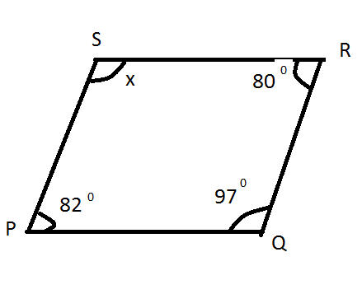
c) Find the value of 'x'? 3

2. a) Draw a geometric shape of cuboid ? 2
b) Count the face, vertices and edges of cuboid ? 3
3. The 4 digits 4,5,0 and 9
a) From greatest number of given digits . 1
b) From smallest number of given digits. 1
c) Find the sum and difference of greatest and
smallest number. 3
4. The height of Mt Everest is 8848m
a) Round of nearest thousand (1000) . 1
b) Write in Roman. 2
c) Write in Devanagari number name. 2
5. a) Which is the Even prime number. 1
b) Find the set of factors of 36 2
c) Factorize 75 into prime factors. 2
6. a) Simplify : 60-75$÷$5 +11× 5 2.5
b) Ram had Rs 100 in his pocket . He spend Rs 30 His
mother gave him Rs 5 .How much is left with Ram ? 2.5

7.a) Identify the fraction $\frac{7}{9}$ and $\frac{9}{7}$ as like or unlike 1
b) Convert 5 $\frac{5}{7}$ into improper fraction. 1
c) Write the three equivalent fraction of $\frac{4}{5}$ 3
8. a) Add: $\frac{4}{10}+ \frac{3}{10}$
b) Subtract: $\frac{2}{3}$-$\frac{1}{3}$ 3
c) Simplify:$\frac{3}{8}+\frac{5}{8}$ -$\frac{1}{8}$ 2
9.a) Define a straight angle . 1
b) A protractor has marked from 0$°$to ........ 1
c) Find the value of 'P' in given straight line . 2
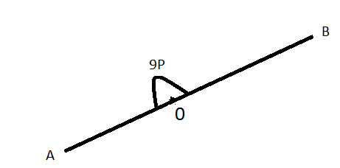

10. a) Write $\frac{202}{10}$ as a decimal . 1
b) Subtract: (5.8-2.451) 2
c) Express $\frac{30}{42}$ in the simplest form . 2

THE END

